
Company
Logotype

Cone Beam Computed Tomography- Report



Porur Dental X-rays & CBCT

Patient Name : Mr. Om Ganesh | Date of Report : 11.09.2024
Age/ Gender : 48 years/ Male | Region of Interest : CBCT Mandible
Referring doctor: Dr. M. Balamurali Sai | Indication : Implant assessment- 35, 36, 37
Clinical Notes: Nil
PATIENT INFORMATION

CBCT- Sectional Mandible provided
CBCT – IMAGE DETAILS

RADIOGRAPHIC INTERPRETATION

- Presence of hyperdense crown structure in relation to 34, 35, 36.
- Complete loss of crown and root structure in relation to 37.
- Presence of hyperdense restorative material within the pulp canal of 35 extending upto the apical third of the root is evident; in addition, a diffuse hypodensity is present in the periapical region of 35.
- The alveolar ridge in relation the mandibular alveolar ridge is present with normal trabecular pattern.

IMPLANT ASSESSMENT

 | 35 region | 36 region | 37 region
Sub-Crestal (in mm) | 7.9 | 7.43 | 7.33
Width along the middle third of alveolar ridge  (in mm) | 9.59 | 9.77 | 9.91
Distance between alveolar ridge and the inferior alveolar nerve canal (in mm) | 14.03 | 13.37 | 11.94
Distance between alveolar ridge and the inferior border of mandible (in mm) | 29.75 | 26.95 | 25.47

RADIOGRAPHIC IMPRESSION

- Root canal treated with periapical pathology: 35
- Crown: 34, 35, 36.
- Partially edentulous region: 37.

Kindly correlate with clinical findings


IMAGES FOR REFERENCE

RECONSTRUCTED PANORAMIC VIEW
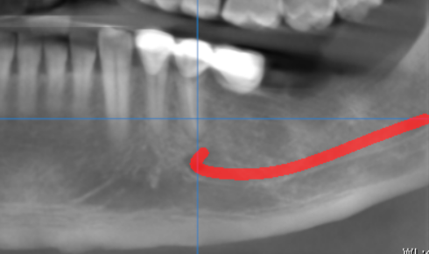

3-DIMENSIONAL VIEW

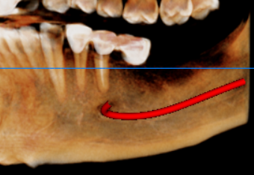

CROSS SECTIONAL VIEW

35 region | 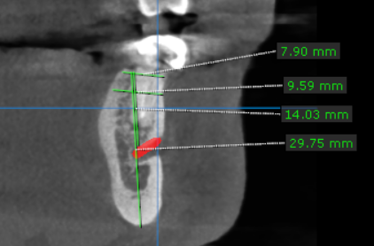
36 region | 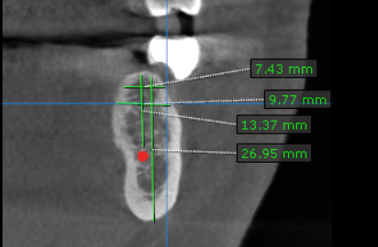
37 region | 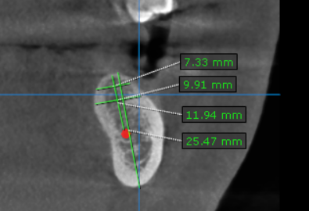

**** End of report ****

